**CPS IX A2**

**SYSTEM DOCUMENTATION**

27th Aug 2019  
  
  
  
Prepare By,  
Siti

### IMPORTANT NOTICE

### ALL RIGHTS RESERVED

Software and documentation are the confidential property and contain the trade secrets of

Prestige Atlantic Asia Sdn Bhd

1-2, Jalan 5/125D, Taman Desa Petaling

57100 Kuala Lumpur

Malaysia

Tel: 603-90573428 Fax: 603-90575088

e-mail: [support@prestigeatlantic.com.my](mailto:support@prestigeatlantic.com.my)

website: [www.prestigeatlantic.com.my](http://www.prestigeatlantic.com.my)

Any copying, use, disclosure, modification, transfer or otherwise must have written consent from

Prestige Atlantic Asia Sdn Bhd

### IMPORTANT NOTICE

### ALL RIGHTS RESERVED

Software and documentation are the confidential property and contain the trade secrets of

Prestige Atlantic Asia Sdn Bhd

1-2, Jalan 5/125D, Taman Desa Petaling

57100 Kuala Lumpur

Malaysia

Tel: 603-90573428 Fax: 603-90575088

e-mail: [support@prestigeatlantic.com.my](mailto:support@prestigeatlantic.com.my)

website: [www.prestigeatlantic.com.my](http://www.prestigeatlantic.com.my)

Any copying, use, disclosure, modification, transfer or otherwise must have written consent from

Prestige Atlantic Asia Sdn Bhd

### IMPORTANT NOTICE

### ALL RIGHTS RESERVED

Software and documentation are the confidential property and contain the trade secrets of

Prestige Atlantic Asia Sdn Bhd

1-2, Jalan 5/125D, Taman Desa Petaling

57100 Kuala Lumpur

Malaysia

Tel: 603-90573428 Fax: 603-90575088

e-mail: [support@prestigeatlantic.com.my](mailto:support@prestigeatlantic.com.my)

website: [www.prestigeatlantic.com.my](http://www.prestigeatlantic.com.my)

Any copying, use, disclosure, modification, transfer or otherwise must have written consent from

Prestige Atlantic Asia Sdn Bhd

### IMPORTANT NOTICE

### ALL RIGHTS RESERVED

Software and documentation are the confidential property and contain the trade secrets of

Prestige Atlantic Asia Sdn Bhd

1-2, Jalan 5/125D, Taman Desa Petaling

57100 Kuala Lumpur

Malaysia

Tel: 603-90573428 Fax: 603-90575088

e-mail: [support@prestigeatlantic.com.my](mailto:support@prestigeatlantic.com.my)

website: [www.prestigeatlantic.com.my](http://www.prestigeatlantic.com.my)

Any copying, use, disclosure, modification, transfer or otherwise must have written consent from

Prestige Atlantic Asia Sdn Bhd

### IMPORTANT NOTICE

### ALL RIGHTS RESERVED

Software and documentation are the confidential property and contain the trade secrets of

Prestige Atlantic Asia Sdn Bhd

1-2, Jalan 5/125D, Taman Desa Petaling

57100 Kuala Lumpur

Malaysia

Tel: 603-90573428 Fax: 603-90575088

e-mail: [support@prestigeatlantic.com.my](mailto:support@prestigeatlantic.com.my)

website: [www.prestigeatlantic.com.my](http://www.prestigeatlantic.com.my)

Any copying, use, disclosure, modification, transfer or otherwise must have written consent from

Prestige Atlantic Asia Sdn Bhd

### IMPORTANT NOTICE

### ALL RIGHTS RESERVED

Software and documentation are the confidential property and contain the trade secrets of

Prestige Atlantic Asia Sdn Bhd

1-2, Jalan 5/125D, Taman Desa Petaling

57100 Kuala Lumpur

Malaysia

Tel: 603-90573428 Fax: 603-90575088

e-mail: [support@prestigeatlantic.com.my](mailto:support@prestigeatlantic.com.my)

website: [www.prestigeatlantic.com.my](http://www.prestigeatlantic.com.my)

Any copying, use, disclosure, modification, transfer or otherwise must have written consent from

Prestige Atlantic Asia Sdn Bhd

Contents

1. Folder 4

2. Program Listing 4

3. System Flow 12

4. Database Dictionary 15

5. PHP Codes 22

6. Javascript Codes 24

7. C++ Codes 30

1. Folder

* All company folder will be placed at /var/www/html/ixa2
* Inside ixa2/ there will be folder for every company with only two/three letter. For example, Prestige Atlantic Asia will be ‘pa’ or ‘paa’ and the folder will be /var/www/html/ixa2/pa/
* Inside every company folder, there will be loginpage.php and all PHP and JS files for the company will be placed in this folder.
* This folder can be access on the web browser using this link 58.84.42.96/ixa2/pa/loginpage.php

1. Program Listing

|  |  |  |  |  |  |  |  |
| --- | --- | --- | --- | --- | --- | --- | --- |
| **No** | **Program ID** | **Program Name** | **Programming** | **Folder** | **Compiler** | **Compiler Version** | **Notes** |
| Login/Logout//Menu/Header/Database connection | | | | | | | |
| 1. | loginpage | Login page. | HTML, CSS, Javacript, PHP | /var/www/html/ixa2/pa | - | - |  |
| 2. | login | To connect loginpage.php to database | PHP | /var/www/html/ixa2/pa | - | - |  |
| 3. | login.js | Contains code to validate form, send form and display error on the same page | Javascript | /var/www/html/ixa2/pa/script | - | - |  |
| 4. | logout | PHP code for logout button. | PHP | /var/www/html/ixa2/pa | - | - |  |
| 5. | menu | Menu page. | PHP | /var/www/html/ixa2/pa | - | - |  |
| 6. | header | Contains header links for loginpage.php | HTML | /var/www/html/ixa2/pa | - | - |  |
| 7. | connectDB2 | To connect to database and receive data from database in JSON format. | PHP | /var/www/html/ixa2/pa | - | - |  |
| 8. | conDB | To connect to database and receive data from database in JSON format for Production. | PHP | /var/www/html/ixa2/pa | - | - |  |
| 9. | db_connect | Database configuration for login.php | PHP | /var/www/html/ixa2/pa | - | - |  |
| Sales Page | | | | | | | |
| 10. | sales | Display sales page. | HTML, CSS, Javacript, PHP | /var/www/html/ixa2/pa | - | - |  |
| 11. | dailychart | Receive and process data from database in JSON format and sent to sales.php | Javascript | /var/www/html/ixa2/pa | - | - |  |
| 12. | comptable | Receive and process data from database in JSON format and sent to sales.php | Javascript | /var/www/html/ixa2/pa | - | - |  |
| 13. | indchart | Receive and process data from database in JSON format and sent to sales.php | Javascript | /var/www/html/ixa2/pa | - | - |  |
| 14. | salesmanChart | Receive and process data from database in JSON format and sent to sales.php | Javascript | /var/www/html/ixa2/pa | - | - |  |
| 15. | uploadsacom | Upload new data or update existing data in sacom.csv to database. | C++ (has MySQL code) | /var/www/html/ixa2/paa2/C++/sacom | GCC  MariaDB | Free Software, 4.8.5  Version 15.1 Distrib 5.5.60- MariaDB for Linux |  |
| 16. | uploadsacod | Upload new data or update existing data in sacod.csv to database | C++ (has MySQL code) | /var/www/html/ixa2/paa2/C++/sacom | GCC  MariaDB | Free Software, 4.8.5  Version 15.1 Distrib 5.5.60- MariaDB for Linux |  |
| 17. | uploadsactm | Upload new data or update existing data in sactm.csv to database. | C++ (has MySQL code) | /var/www/html/ixa2/paa2/C++/sacom | GCC  MariaDB | Free Software, 4.8.5  Version 15.1 Distrib 5.5.60- MariaDB for Linux |  |
| 18. | uploadsaidm | Upload new data or update existing data in saidm.csv to database. | C++ (has MySQL code) | /var/www/html/ixa2/paa2/C++/sacom | GCC  MariaDB | Free Software, 4.8.5  Version 15.1 Distrib 5.5.60- MariaDB for Linux |  |
| 19. | uploadsasmm | Upload new data or update existing data in sasmm.csv to database. | C++ (has MySQL code) | /var/www/html/ixa2/paa2/C++/sacom | GCC  MariaDB | Free Software, 4.8.5  Version 15.1 Distrib 5.5.60- MariaDB for Linux |  |
| Production Page | | | | | | | |
| 20. | pm | Display production page. | HTML, CSS, Javacript, PHP | /var/www/html/ixa2/pa | - | - |  |
| 21. | pmcrd | Receive and process data from database in JSON format and sent to pm.php | Javascript | /var/www/html/ixa2/pa/pm | - | - |  |
| 22. | uploadpmcrd | Upload new data or update existing data in pmcrd.csv to database. | C++ (has MySQL code) | /var/www/html/ixa2/paa2/C++/sacom | GCC  MariaDB | Free Software, 4.8.5  Version 15.1 Distrib 5.5.60- MariaDB for Linux |  |
| 23. | uploadpmfxd | Upload new data or update existing data in pmfxd.csv to database. | C++ (has MySQL code) | /var/www/html/ixa2/paa2/C++/sacom | GCC  MariaDB | Free Software, 4.8.5  Version 15.1 Distrib 5.5.60- MariaDB for Linux |  |
| Warehouse Page | | | | | | | |
| 24. | wh | Display warehouse page. | HTML, CSS, Javacript, PHP | /var/www/html/ixa2/pa | - | - |  |
| 25. | fgbal | Receive and process data from database and sent to wh.php | Javascript | /var/www/html/ixa2/pa/pm | - | - |  |
| 26. | uploadfgbal | Upload new data or update existing data in fgbal.csv to database. | C++ (has MySQL code) | /var/www/html/ixa2/paa2/C++/sacom | GCC  MariaDB | Free Software, 4.8.5  Version 15.1 Distrib 5.5.60- MariaDB for Linux |  |
| Paper Roll Page | | | | | | | |
| 27. | pr | Display paper roll page. | HTML, CSS, Javacript, PHP | /var/www/html/ixa2/pa | - | - |  |
| 28. | prtable | Receive and process data from database and sent to pr.php | Javascript | /var/www/html/ixa2/pa/pm | - | - |  |
| 29. | uploadprbal | Upload new data or update existing data in prbal.csv to database. | C++ (has MySQL code) | /var/www/html/ixa2/paa2/C++/sacom | GCC  MariaDB | Free Software, 4.8.5  Version 15.1 Distrib 5.5.60- MariaDB for Linux |  |
| Material Page | | | | | | | |
| 30. | mm.php | Display material page. | HTML, CSS, Javacript, PHP | /var/www/html/ixa2/pa | - | - |  |
| 31. | materialtable | Receive and process data from database and sent to mm.php | Javascript | /var/www/html/ixa2/pa/pm | - | - |  |
| 32. | uploadmmbal | Upload new data or update existing data in mmbal.csv to database. | C++ (has MySQL code) | /var/www/html/ixa2/paa2/C++/sacom | GCC  MariaDB | Free Software, 4.8.5  Version 15.1 Distrib 5.5.60- MariaDB for Linux |  |
| Plant Maintenance Page | | | | | | | |
| 33. | p1 | Display plant maintenance page. | HTML, CSS, Javacript, PHP | /var/www/html/ixa2/pa | - | - |  |
| 34. | plantmaintenance | Receive and process data from database and sent to p1.php | Javascript | /var/www/html/ixa2/pa | - | - |  |
| 35. | uploadp1cal | Upload new data or update existing data in p1cal.csv to database. | C++ (has MySQL code) | /var/www/html/ixa2/paa2/C++/sacom | GCC  MariaDB | Free Software, 4.8.5  Version 15.1 Distrib 5.5.60- MariaDB for Linux |  |
| 36. | uploadp1mch | Upload new data or update existing data in p1mch.csv to database. | C++ (has MySQL code) | /var/www/html/ixa2/paa2/C++/sacom | GCC  MariaDB | Free Software, 4.8.5  Version 15.1 Distrib 5.5.60- MariaDB for Linux |  |
| Finance Page | | | | | | | |
| 37. | fm.php | Display finance page. | HTML, CSS, Javacript, PHP | /var/www/html/ixa2/pa | - | - |  |
| 38. | finance | Receive and process data from database and sent to fm.php. | Javascript | /var/www/html/ixa2/pa | - | - |  |
| 39. | fmpie | Receive and process data from database and sent to fm.php. | Javascript | /var/www/html/ixa2/pa | - | - |  |
| 40. | uploadfmar | Upload new data or update existing data in fmar.csv to database. | C++ (has MySQL code) | /var/www/html/ixa2/paa2/C++/sacom | GCC  MariaDB | Free Software, 4.8.5  Version 15.1 Distrib 5.5.60- MariaDB for Linux |  |
| 41. | uploadfmap | Upload new data or update existing data in fmap.csv to database. | C++ (has MySQL code) | /var/www/html/ixa2/paa2/C++/sacom | GCC  MariaDB | Free Software, 4.8.5  Version 15.1 Distrib 5.5.60- MariaDB for Linux |  |
| 42. | uploadfmgl | Upload new data or update existing data in fmgl.csv to database. | C++ (has MySQL code) | /var/www/html/ixa2/paa2/C++/sacom | GCC  MariaDB | Free Software, 4.8.5  Version 15.1 Distrib 5.5.60- MariaDB for Linux |  |
| Admin | | | | | | | |
| 43. | sam | Admin homepage. | HTML, CSS, Javacript, PHP | /var/www/html/ixa2/pa | - | - |  |
| 44. | setupUser | Search user for add or update. | HTML, CSS, Javacript, PHP | /var/www/html/ixa2/pa | - | - |  |
| 45. | registerpage | Add or update user details. | HTML, CSS, Javacript, PHP | /var/www/html/ixa2/pa | - | - |  |
| 46. | register | Query database to check, add, update and save user to database. | HTML, CSS, Javacript, PHP | /var/www/html/ixa2/pa | - | - |  |
| 47. | register.js | Validate and submit registerpage form. | Javascript | /var/www/html/ixa2/pa/script | - | - |  |
| 48. | setupPermission | Search user for setup permission. | HTML, CSS, Javacript, PHP | /var/www/html/ixa2/pa | - | - |  |
| 49. | permissionpage | Update user permission. | HTML, CSS, Javacript, PHP | /var/www/html/ixa2/pa | - | - |  |
| 50. | permission | Query database to update and save user permission to database. | HTML, CSS, Javacript, PHP | /var/www/html/ixa2/pa | - | - |  |
| 51. | permission.js | Validate and submit permissionpage form. | Javascript | /var/www/html/ixa2/pa/script | - | - |  |
| Cobol | | | | | | | |
| 52. | IXA2 | Main program to call IXSACOM & IXSACOD. | COBOL | /v/cps/plugin/ixa2/prg |  |  |  |
| 53. | IXSACOD | Process sales daily for this month and last month and keep into CSV. | COBOL | /v/cps/plugin/ixa2/prg |  |  |  |
| 54. | IXSACOM | Process sales month for this year and last year and keep into CSV. | COBOL | /v/cps/plugin/ixa2/prg |  |  |  |
| 55. | IXA2 | Windows task scheduler to run IXASCOD + IXSACOM + FTP CSV into Windows and FTP to CentOS server. | ALIAS COBOL | 128.0.0.246 |  |  |  |

1. System Flow
2. Front-End

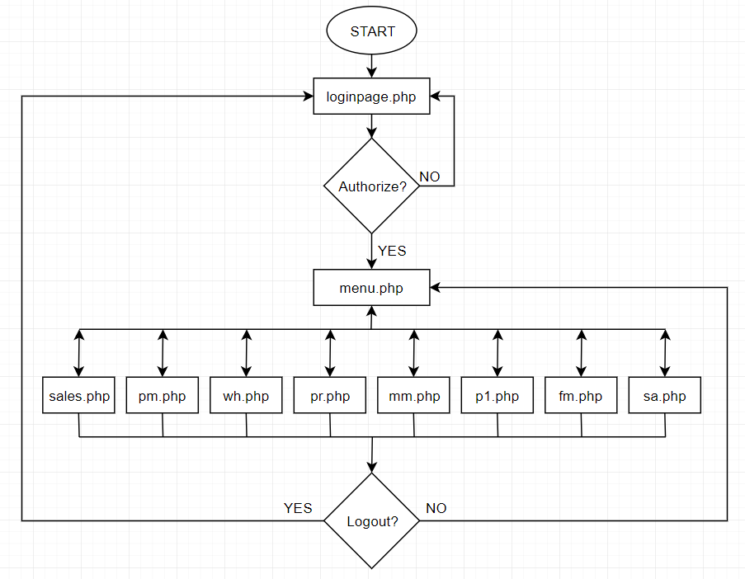

1. Back-End

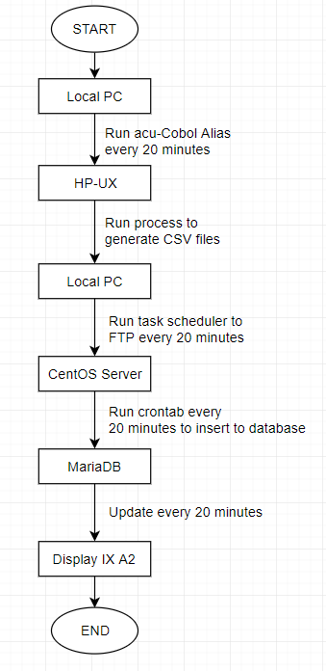

**PROCESS 1 (Local PC to HP-UX)**

1. IXA2 run acu-Cobol alias to get the data from HP-UX server every 20 minutes.

**PROCESS 2 (HP-UX to Local PC)**

1. HP-UX process the CSV files and FTP to Local PC.

**POCESS 3 (Local PC to CentOS Server)**

1. Task scheduler will run IXA2.bat every 20 minutes to FTP CSV files.
2. Run IXA2.bat to FTP the CSV files to CentOS Server.

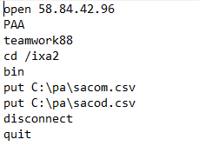

Figure 1: IXA2.bat



Figure 2: Run IXA2.bat

**PROCESS 4 (CentOS Server to MariaDB)**

1. Crontab will run IXA2 every 20 minutes to move CSV files from home/PAA/ixa2 to /var/www/html/ixa2/paa2/C++/sacom and execute C++ program.
2. This will insert all CSV data into MariaDB.
3. Database Dictionary

Database name: mobile

Contain 6 tables in the database: sacodData, sacomdata, sactmData, saidmData, plData and userID.

N/A: Not Applicable (data are not been used to display data).

1. **sacomdata**

Save data for every month to generate monthly sales bar chart.

|  |  |  |  |  |
| --- | --- | --- | --- | --- |
| **Attribute Name** | **Attribute Type** | **Description** | **Size** | **Key** |
| year | Varchar | Save year data. | 4 |  |
| dateym | Varchar | Save full date data. | 6 | Primary Key |
| mt1 | Varchar | N/A | 11 |  |
| m21 | Varchar | N/A | 13 |  |
| amt1 | Varchar | N/A | 15 |  |
| mt2 | Varchar | N/A | 11 |  |
| m22 | Varchar | N/A | 13 |  |
| amt2 | Varchar | N/A | 15 |  |
| mt3 | Varchar | N/A | 11 |  |
| m23 | Varchar | N/A | 13 |  |
| amt3 | Varchar | N/A | 15 |  |
| mtt | Varchar | Sava metric ton data. | 11 |  |
| m2t | Varchar | Save metric square data. | 13 |  |
| amtt | Varchar | Save sales amount. | 15 |  |
| budget | Varchar | N/A | 15 |  |
| variance | Varchar | N/A | 15 |  |
| percent | Varchar | N/A | 8 |  |

1. **sacodData**

Save daily record to generate daily sales line chart.

|  |  |  |  |  |
| --- | --- | --- | --- | --- |
| **Attribute Name** | **Attribute Type** | **Description** | **Size** | **Key** |
| year | Varchar | Save year data. | 4 |  |
| month | Varchar | Save month data. | 2 |  |
| date | Varchar | Save data data. | 2 |  |
| dateym | Varchar | Save full date data. | 8 | Primary Key |
| intakemt | Varchar | N/A | 11 |  |
| intakem2 | Varchar | N/A | 13 |  |
| intakeamt | Varchar | N/A | 15 |  |
| duemt | Varchar | N/A | 11 |  |
| duem2 | Varchar | N/A | 13 |  |
| dueamt | Varchar | N/A | 15 |  |
| domt | Varchar | N/A | 11 |  |
| dom2 | Varchar | N/A | 13 |  |
| doamt | Varchar | N/A | 15 |  |
| mt1 | Varchar | N/A | 11 |  |
| m21 | Varchar | N/A | 13 |  |
| amt1 | Varchar | N/A | 15 |  |
| mt2 | Varchar | N/A | 11 |  |
| m22 | Varchar | N/A | 13 |  |
| amt2 | Varchar | N/A | 15 |  |
| mt3 | Varchar | N/A | 11 |  |
| m23 | Varchar | N/A | 13 |  |
| amt3 | Varchar | N/A | 15 |  |
| mtt | Varchar | Sava metric ton data. | 11 |  |
| m2t | Varchar | Save metric square data. | 13 |  |
| amtt | Varchar | Save sales amount. | 15 |  |

1. **sactmData**

Save companies’ details to generate customer sales table.

|  |  |  |  |  |
| --- | --- | --- | --- | --- |
| **Attribute Name** | **Attribute Type** | **Description** | **Size** | **Key** |
| compcode | Varchar | Save company’s code data. | 20 | Primary Key |
| compname | Varchar | Save company’s name data. | 60 |  |
| year | Varchar | Save year data. | 4 |  |
| month | Varchar | Save month data. | 2 |  |
| dateym | Varchar | Save full date data. | 6 | Primary Key |
| mtt | Decimal | Sava metric ton data. | 13,2 |  |
| m2t | Decimal | Save metric square data. | 16,2 |  |
| amtt | Decimal | Save sales amount. | 18,2 |  |

1. **saidmData**

Save every month industry’s data to generate monthly industry sales pie chart.

|  |  |  |  |  |
| --- | --- | --- | --- | --- |
| **Attribute Name** | **Attribute Type** | **Description** | **Size** | **Key** |
| indcode | Varchar | Save industry’s code. | 5 | Primary Key |
| indname | Varchar | Save industry’s name. | 35 |  |
| year | Varchar | Save year data. | 4 |  |
| month | Varchar | Save month data. | 2 |  |
| dateym | Varchar | Save full date data. | 6 | Primary Key |
| mtt | Decimal | Sava metric ton data. | 13,2 |  |
| m2t | Decimal | Save metric square data. | 16,2 |  |
| amtt | Decimal | Save sales amount. | 18,2 |  |

1. **sasmmData**

Save salesman data to generate salesman sale pie chart.

|  |  |  |  |  |
| --- | --- | --- | --- | --- |
| **Attribute Name** | **Attribute Type** | **Description** | **Size** | **Key** |
| salesPersonCode | Varchar | Save salesman code. | 5 | Primary Key |
| salesPersonName | Varchar | Save salesman name. | 35 |  |
| year | Int | Save year data. | 4 |  |
| month | Int | Save month data. | 2 |  |
| dateym | Int | Save full date data. | 6 | Primary Key |
| mtt | Decimal | Sava metric ton data. | 13,2 |  |
| m2t | Decimal | Save metric square data. | 16,2 |  |
| amtt | Decimal | Save sales amount. | 18,2 |  |

1. **pmcrdData**

Save corrugators data to display stepped chart.

|  |  |  |  |  |
| --- | --- | --- | --- | --- |
| **Attribute Name** | **Attribute Type** | **Description** | **Size** | **Key** |
| macCode | Varchar | Save machine code. | 5 | Primary Key |
| macName | Varchar | Save machine name. | 20 |  |
| start | Varchar | Save machine start time. | 5 | Primary Key |
| End | Varchar | Save machine end time. | 5 | Primary Key |
| lm | Decimal | Save machine lm data. | 14,2 | Primary Key |

1. **pmfxdData**

Save flexos data to display stepped chart.

|  |  |  |  |  |
| --- | --- | --- | --- | --- |
| **Attribute Name** | **Attribute Type** | **Description** | **Size** | **Key** |
| macCode | Varchar | Save machine code. | 5 | Primary Key |
| macName | Varchar | Save machine name. | 20 |  |
| start | Varchar | Save machine start time. | 5 | Primary Key |
| End | Varchar | Save machine end time. | 5 | Primary Key |
| lm | Decimal | Save machine lm data. | 14,2 | Primary Key |

1. **fgbalData**

Save warehouse data to display warehouse table.

|  |  |  |  |  |
| --- | --- | --- | --- | --- |
| **Attribute Name** | **Attribute Type** | **Description** | **Size** | **Key** |
| acNo | Varchar | Save company acc number. | 12 | Primary Key |
| mcsNo | Varchar | Save master card number | 12 |  |
| customer | Varchar | Save customer name. | 50 |  |
| model | Varchar | Save model data. | 50 |  |
| pd | Varchar | Save product design data. | 8 |  |
| ed | Varchar | Save external design data. | 18 |  |
| id | Varchar | Save internal design data. | 18 |  |
| fgQty | Decimal | Save fg quantity data. | 6,0 |  |
| onem | Decimal | Save 1 month data. | 6,0 |  |
| twom | Decimal | Save 2 months data. | 6,0 |  |
| threem | Decimal | Save 3 months data. | 6,0 |  |
| fourm | Decimal | Save 4 months data. | 6,0 |  |
| fivem | Decimal | Save 5 months data. | 6,0 |  |
| fivemp | Decimal | Save 5 months plus data. | 6,0 |  |

1. **prData**

Save paper roll data to display paper roll balance table.

|  |  |  |  |  |
| --- | --- | --- | --- | --- |
| **Attribute Name** | **Attribute Type** | **Description** | **Size** | **Key** |
| type | Varchar | Save type data. | 2 | Primary Key |
| gsm | Varchar | Save gsm data. | 2 | Primary Key |
| size | Int | Save size data. | 4 | Primary Key |
| supp | Varchar | Save sup data. | 8 | Primary Key |
| frroll | Int | Save fr roll data. | 6 |  |
| frmt | Decimal | Save fr mt data. | 8,2 |  |
| brroll | Int | Save br roll data. | 6 |  |
| brmt | Decimal | Save br mt data. | 8,2 |  |
| rolmt | Decimal | Save rol mt data. | 8,2 |  |
| fporoll | Int | Save fpo roll data. | 6 |  |
| fpomt | Decimal | Save fpo mt data. | 8,2 |  |
| status | Varchar | Save ok or ng data. | 2 |  |

1. **mmData**

Save material data to display material table.

|  |  |  |  |  |
| --- | --- | --- | --- | --- |
| **Attribute Name** | **Attribute Type** | **Description** | **Size** | **Key** |
| cat | Varchar | Save cat data. | 6 |  |
| skuNo | Varchar | Save sku no data. | 15 | Primary Key |
| name | Varchar | Save material name data. | 30 |  |
| bal | Decimal | Save balance data. | 12,2 |  |
| unit | Varchar | Save unit data. | 6 |  |
| rol | Decimal | Save rol data. | 12,2 |  |
| fpo | Decimal | Save fpo data. | 12,2 |  |
| ok | Varchar | Save ok or ng data. | 2 |  |

1. **p1Data**

Save calendar’s task and details.

|  |  |  |  |  |
| --- | --- | --- | --- | --- |
| **Attribute Name** | **Attribute Type** | **Description** | **Size** | **Key** |
| year | Varchar | Save year data. | 4 |  |
| month | Varchar | Save month data. | 2 |  |
| day | Varchar | Save day data. | 2 |  |
| days | Varchar | Save day (Mon-Sun) data. | 3 |  |
| dateym | Date | Save full date. |  | Primary Key |
| ph | Varchar | Save public holiday data. | 12 |  |
| daysWord1 | Varchar | Save process data days for machine 1. | 2 |  |
| machineCode1 | Varchar | Save machine code for machine 1. | 12 | Primary Key |
| machineName1 | Varchar | Save machine name for machine 1. | 50 |  |
| type1 | Varchar | Save type for machine 1. | 2 |  |
| daysWord2 | Varchar | Save process data days for machine 2. | 2 |  |
| machineCode2 | Varchar | Save machine code for machine 2. | 12 | Primary Key |
| machineName2 | Varchar | Save machine name for machine 2. | 50 |  |
| type2 | Varchar | Save type for machine 2. | 2 |  |
| daysWord3 | Varchar | Save process data days for machine 3. | 2 |  |
| machineCode3 | Varchar | Save machine code for machine 3. | 12 | Primary Key |
| machineName3 | Varchar | Save machine name for machine 3. | 50 |  |
| type3 | Varchar | Save type for machine 3. | 2 |  |

1. **p1mchData**

Save plant machine budget data to display table.

|  |  |  |  |  |
| --- | --- | --- | --- | --- |
| **Attribute Name** | **Attribute Type** | **Description** | **Size** | **Key** |
| mch | Varchar | Save machine code. | 8 | Primary key |
| name | Varchar | Save machine name. | 30 |  |
| actual | Decimal | Save actual amount data. | 12,2 |  |
| budget | Decimal | Save decimal amount data. | 12,2 |  |
| percent | Decimal | Save percentage amount. | 12,2 |  |

1. **fmarData**

Save customer data to display table and pie chart.

|  |  |  |  |  |
| --- | --- | --- | --- | --- |
| **Attribute Name** | **Attribute Type** | **Description** | **Size** | **Key** |
| acNo | Varchar | Save customer acc no. | 12 |  |
| name | Varchar | Save customer name. | 50 | Primary Key |
| curr | Varchar | Save currency data. | 6 |  |
| lTotal | Decimal | Save local total | 12,2 |  |
| l1M | Decimal | Save local 1 month. | 12,2 |  |
| l2M | Decimal | Save local 2 months. | 12,2 |  |
| l3M | Decimal | Save local 3 months. | 12,2 |  |
| l4M | Decimal | Save local 4 months | 12,2 |  |
| l5M | Decimal | Save local 5 months. | 12,2 |  |
| l5Mp | Decimal | Save local 5 months plus. |  |  |

1. **fmapData**

Save supplier data to display table and pie chart.

|  |  |  |  |  |
| --- | --- | --- | --- | --- |
| **Attribute Name** | **Attribute Type** | **Description** | **Size** | **Key** |
| acNo | Varchar | Save customer acc no. | 12 |  |
| name | Varchar | Save customer name. | 50 | Primary Key |
| curr | Varchar | Save currency data. | 6 |  |
| lTotal | Decimal | Save local total | 12,2 |  |
| l1M | Decimal | Save local 1 month. | 12,2 |  |
| l2M | Decimal | Save local 2 months. | 12,2 |  |
| l3M | Decimal | Save local 3 months. | 12,2 |  |
| l4M | Decimal | Save local 4 months | 12,2 |  |
| l5M | Decimal | Save local 5 months. | 12,2 |  |
| l5Mp | Decimal | Save local 5 months plus. |  |  |

1. **fmglData**

Save trial balance data to display table.

|  |  |  |  |  |
| --- | --- | --- | --- | --- |
| **Attribute Name** | **Attribute Type** | **Description** | **Size** | **Key** |
| acNo | Varchar | Save company acc no. | 15 | Primary Key |
| name | Varchar | Save company name. | 50 |  |
| bf | Decimal | Save bf data. | 12,2 |  |
| dr | Decimal | Save dr data. | 12,2 |  |
| cr | Decimal | Save cr data. | 12,2 |  |
| cls | Decimal | Save cls data. | 12,2 |  |

1. **userID**

All registered user’s data will be saved in this table and use as login table.

|  |  |  |  |  |
| --- | --- | --- | --- | --- |
| **Attribute Name** | **Attribute Type** | **Description** | **Size** | **Key** |
| usrID | Varchar | Every user will have different user id. | 6 | Primary Key |
| usrPwd | Varchar | User password to login. | 6 |  |
| usrName | Varchar | Save user’s name. | 60 |  |
| dataname | Varchar | Company name to access data based on company. | 50 |  |

1. PHP Codes
2. login.php

Back-end process to check user when login.

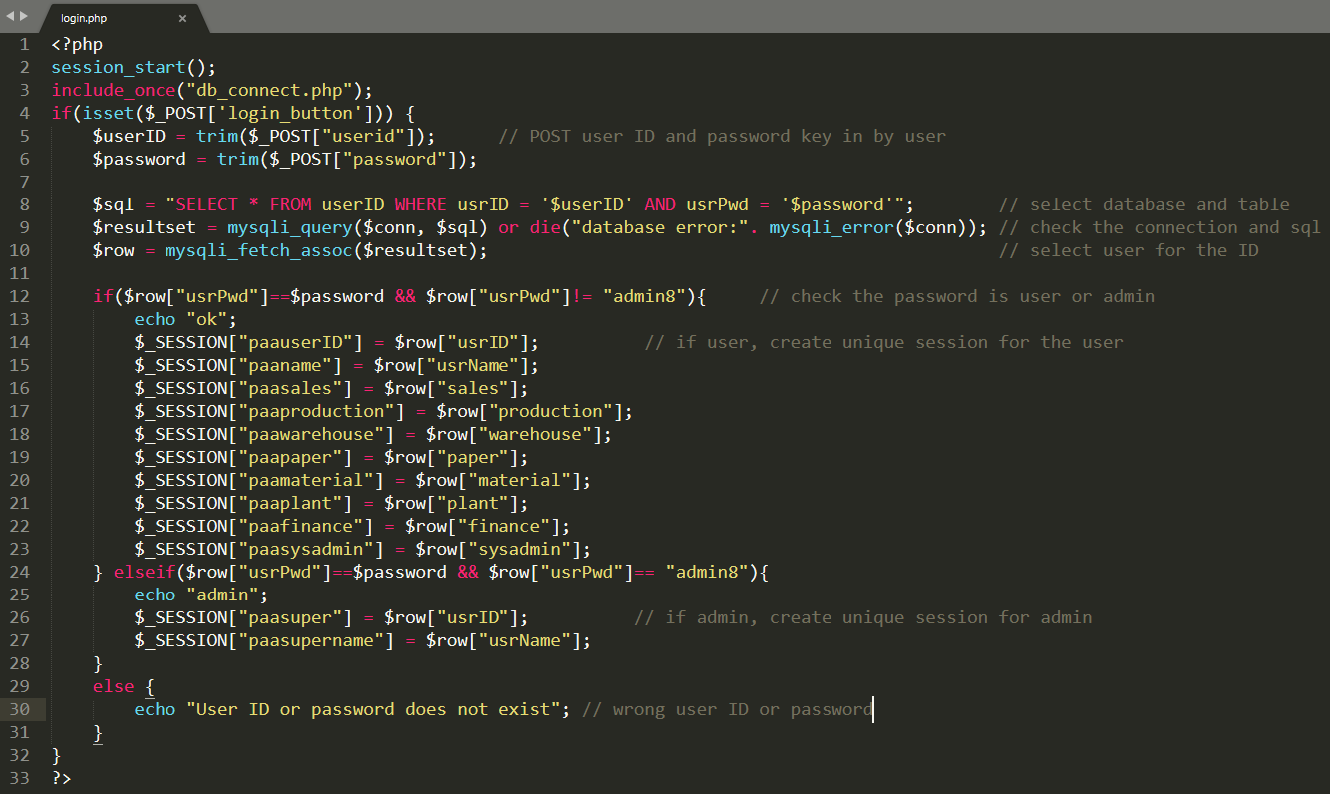

1. logout.php

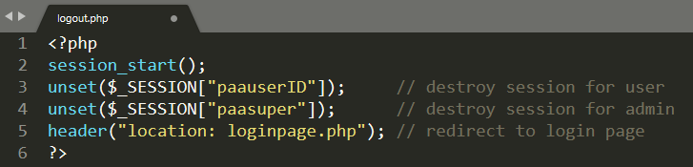

1. connectDB2.php

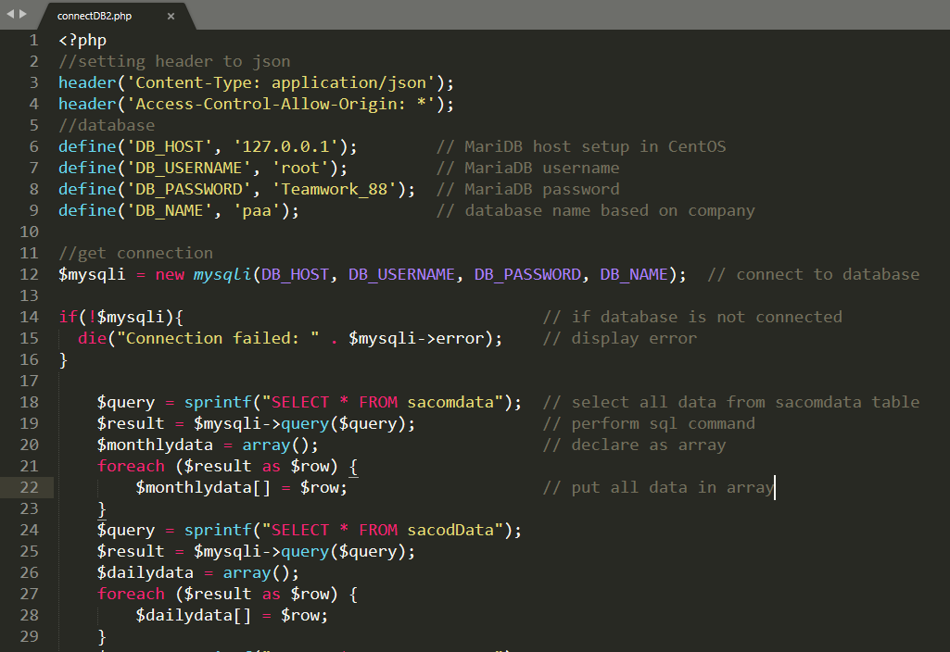

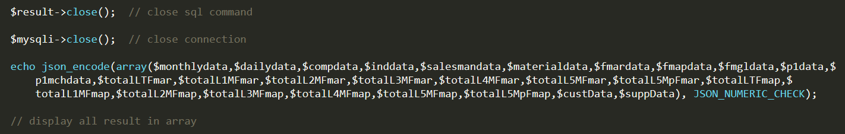

1. menu.php

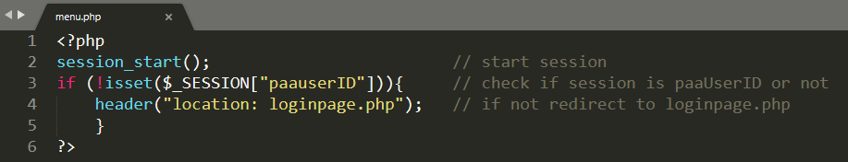

1. PHP for Modules (ex: sales.php, pm.php, wh.php and etc)

* Must start the session to distinguish the logged in user.

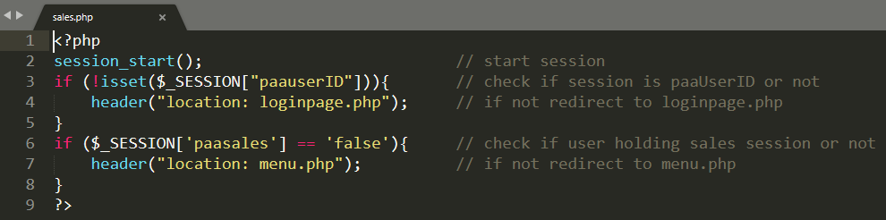

1. Javascript Codes
2. Get current/previous year and month

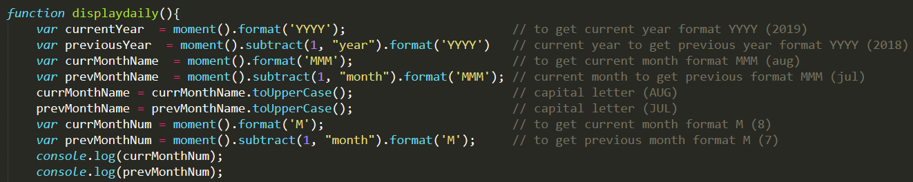

1. Connect JS to database

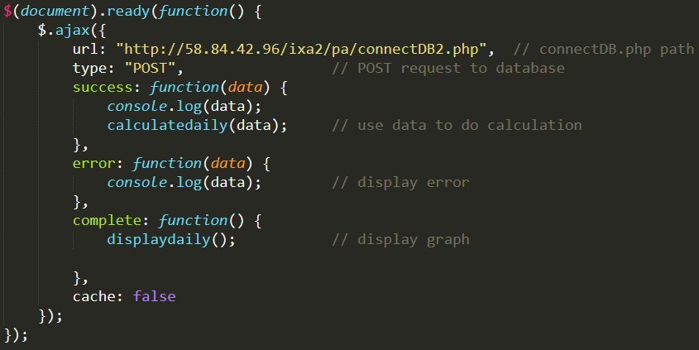

1. Bar chart setup

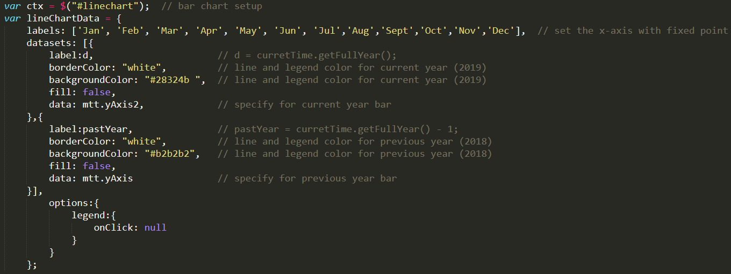

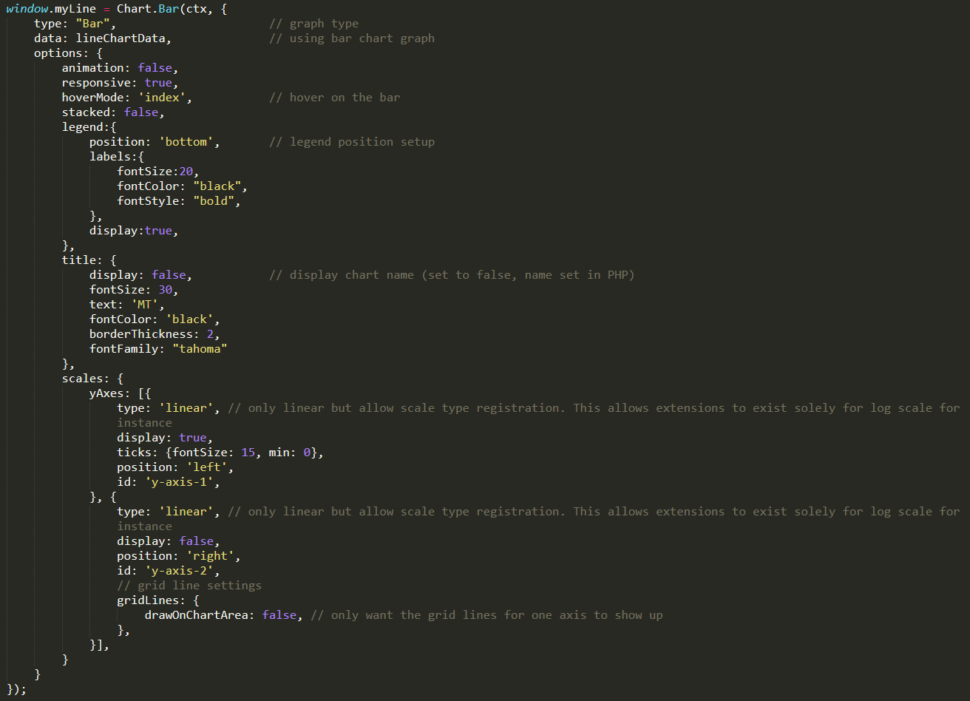

1. Line graph setup

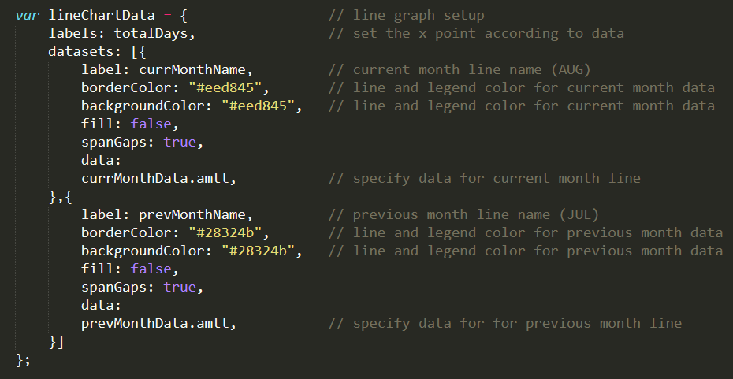

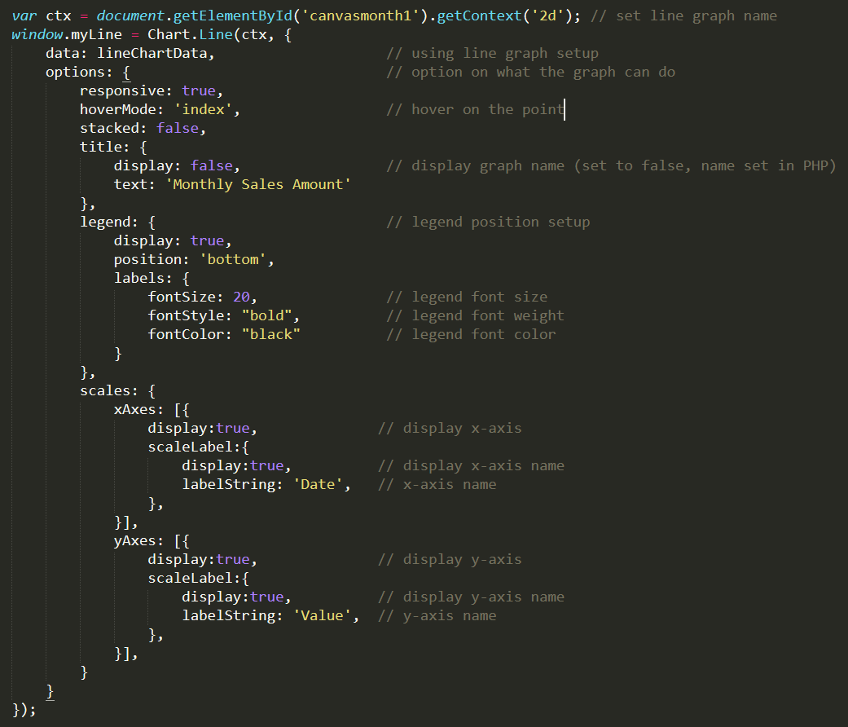

1. Table setup

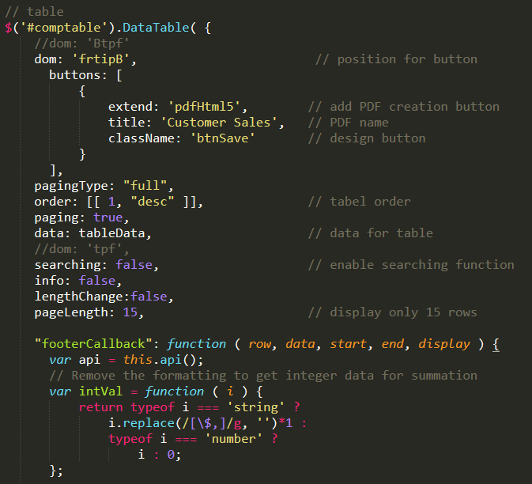

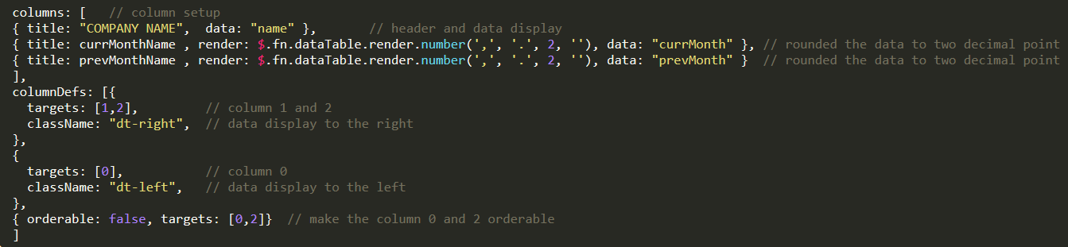



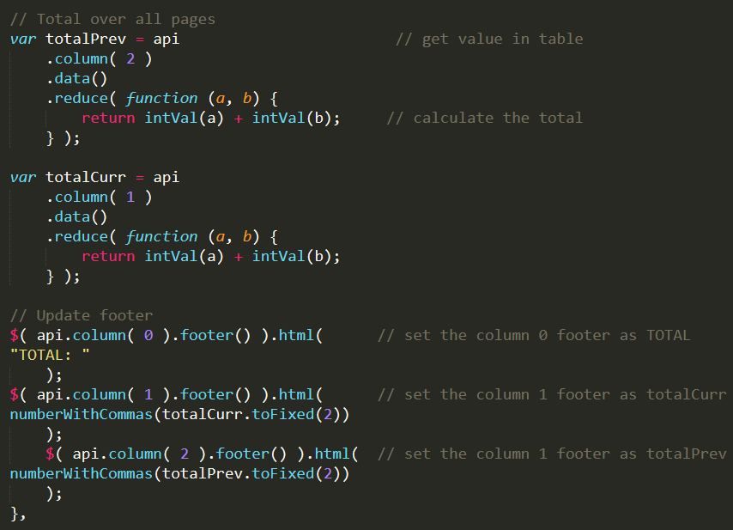

1. Pie chart

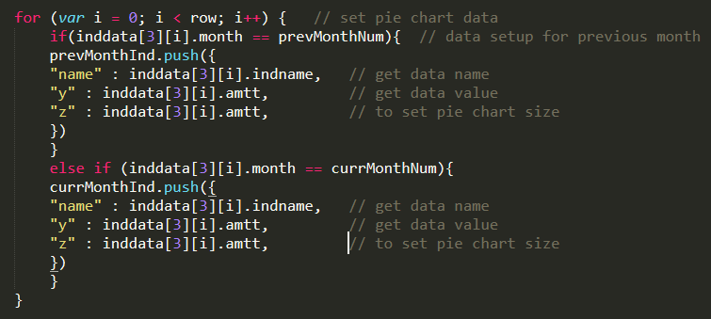

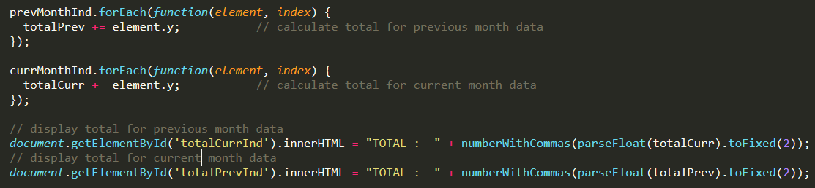

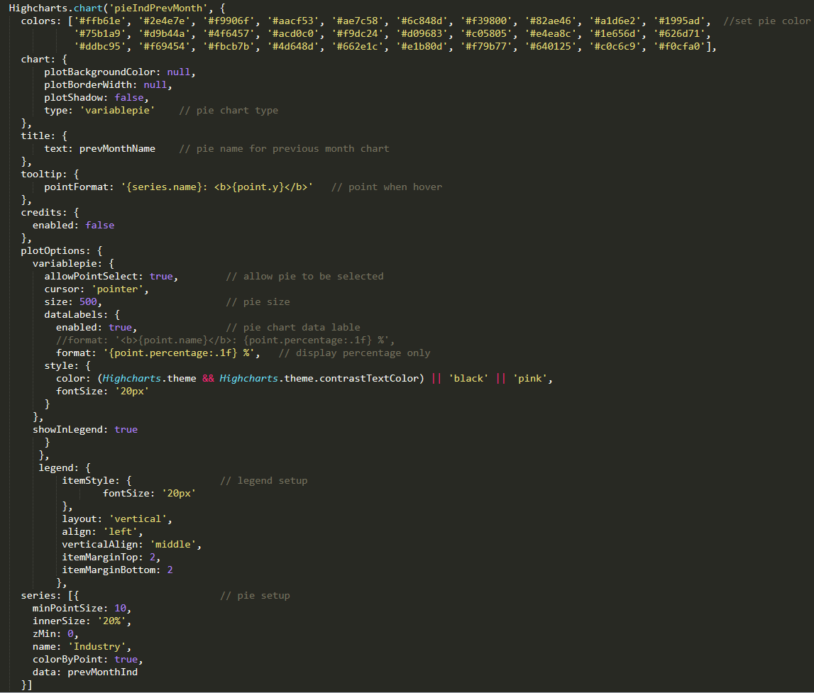

1. C++ Codes

